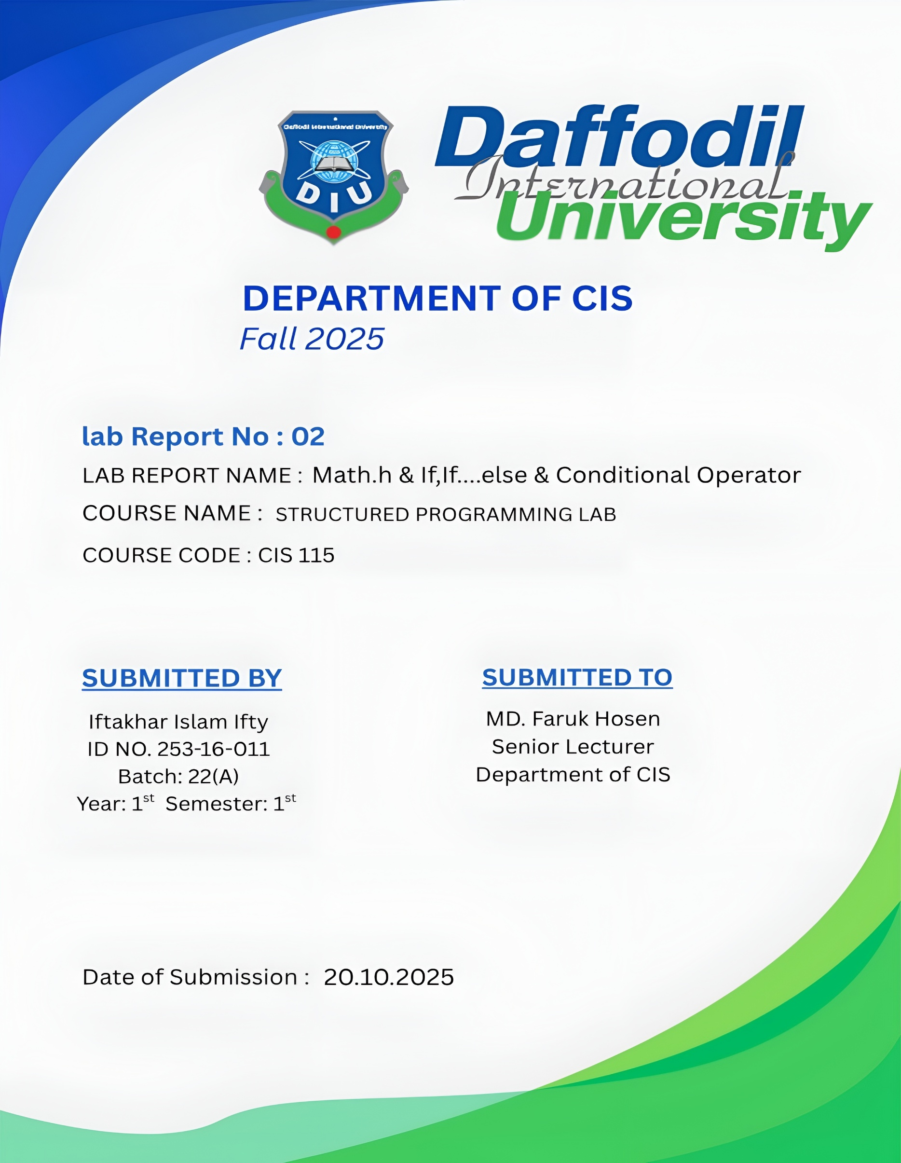

Math.h

Problem No: 01
Problem Name: Write a program that read any integer
and display absolute value.

Source Code:
#include <stdio.h>
#include <stdlib.h>
int main()
{
int n;
printf("Enter any integer:");
scanf("%d",&n);
printf("abs(%d)=%d",n,abs(n));
return 0;
}

Output :
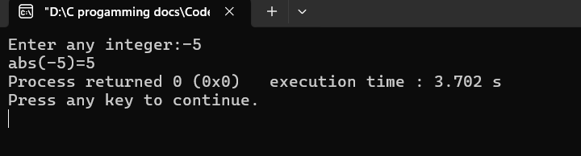

Problem No: 02
Problem Name: Write a program that read any angle ‘t’
and display sin(t).

Source Code:
#include <stdio.h>
#include <math.h>

int main()
{
int t;
printf("Enter any angle:");
scanf("%d",&t);
printf("sin(%d)=%2f",t,sin(t*M_PI/180));

return 0;
}
Output :
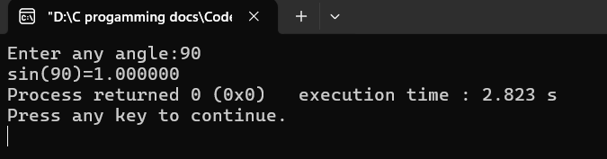

Problem No: 03
Problem Name: Write a program that read any angle ‘t’
and display cos(t).

Source Code:
#include <stdio.h>
#include <math.h>

int main()
{
int t;
printf("Enter any angle:");
scanf("%d",&t);
printf("cos(%d)=%2f",t,cos(t*M_PI/180));

return 0;
}

Output :
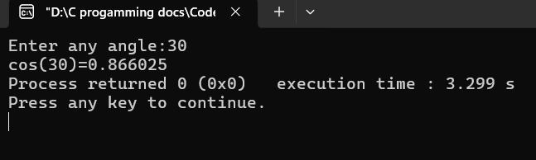

Problem No: 04
Problem Name: Write a program that read any angle ‘t’
and display tan(t).

Source Code:
#include <stdio.h>
#include <math.h>

int main()
{
int t;
printf("Enter any angle:");
scanf("%d",&t);
printf("tan(%d)=%2f",t,tan(t*M_PI/180));

return 0;
}

Output :
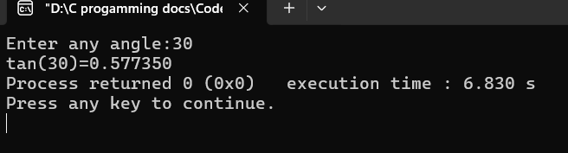

Problem No: 05
Problem Name: Write a program that read any angle ‘t’
and display cot(t).

Source Code:
#include <stdio.h>
#include <math.h>

int main()
{
int t;
printf("Enter any angle:");
scanf("%d",&t);
printf("cot(%d)=%2f",t,1/tan(t*M_PI/180));

return 0;
}

Output :
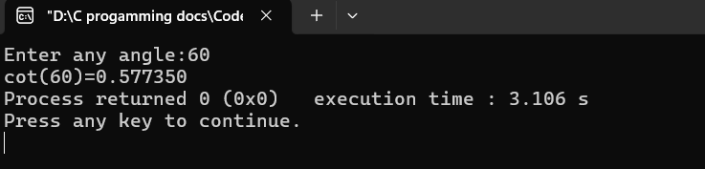

Problem No: 06
Problem Name: Write a program that read any angle ‘t’
and display sec(t).

Source Code:
#include <stdio.h>
#include <math.h>

int main()
{
int t;
printf("Enter any angle:");
scanf("%d",&t);
printf("sec(%d)=%2f",t,1/cos(t*M_PI/180));

return 0;
}

Output :
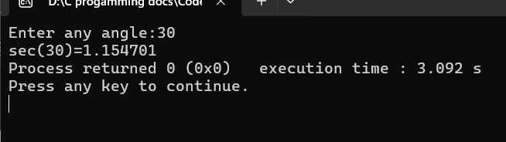

Problem No: 07
Problem Name: Write a program that read any angle ‘t’
and display cosec(t).

Source Code:
#include <stdio.h>
#include <math.h>

int main()
{
int t;
printf("Enter any angle:");
scanf("%d",&t);
printf("cosec(%d)=%2f",t,1/sin(t*M_PI/180));

return 0;
}
Output :
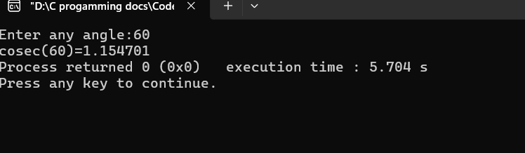

Problem No: 08
Problem Name: Write a program that read a value ‘a’
and display sin inverse(n).

Source Code:
#include <stdio.h>
#include <math.h>

int main()
{
float n;
printf("Enter any angle:");
scanf("%f",&n);
printf("sin inverse(%.2f)=%.2f",n,asin(n)*180/M_PI);

return 0;
}

Output :
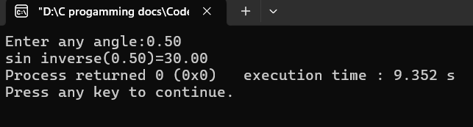

Problem No: 10
Problem Name: Write a program that read a value ‘a’
and display tan inverse(n).

Source Code:
#include <stdio.h>
#include <math.h>

int main()
{
float n;
printf("Enter any angle:");
scanf("%f",&n);
printf("tan inverse(%.2f)=%.2f",n,atan(n)*180/M_PI);

return 0;
}

Output :
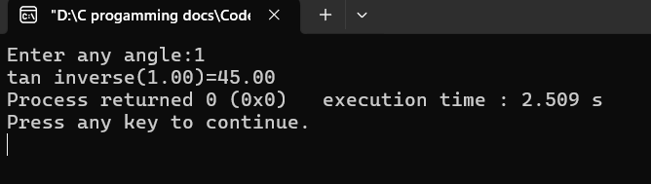

Problem No: 11
Problem Name: Write a program that read a value ‘a’
and display cot inverse(n).

Source Code:
#include <stdio.h>
#include <math.h>

int main()
{
float n;
printf("Enter any angle:");
scanf("%f",&n);
printf("Cot inverse(%.2f)= %.2f",n, atan(1.0/n)*180/M_PI);

return 0;
}

Output :
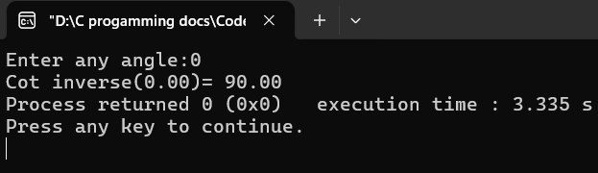

Problem No: 12
Problem Name: Write a program that read a value ‘a’
and display sec inverse(n).

Source Code:
#include <stdio.h>
#include <math.h>

int main()
{
float n;
printf("Enter any angle:");
scanf("%f",&n);
printf("sec inverse(%.2f)= %.2f",n, acos(1.0/n)*180/M_PI);

return 0;
}

Output :
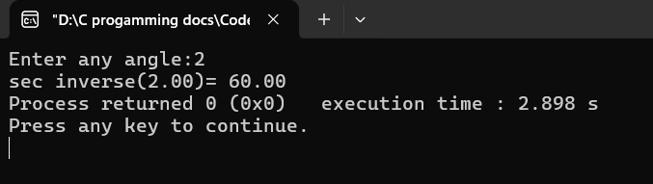

Problem No: 13
Problem Name: Write a program that read a value ‘a’
and display cosec inverse(n).

Source Code:
#include <stdio.h>
#include <math.h>

int main()
{
float n;
printf("Enter any angle:");
scanf("%f",&n);
printf("cosec inverse(%.2f)= %.2f",n, asin(1.0/n)*180/M_PI);

return 0;
}

Output :
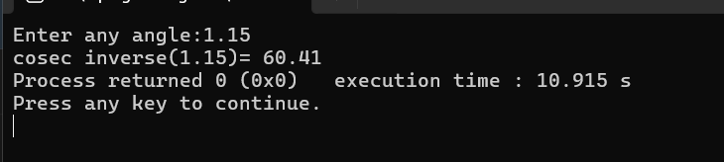

Problem No: 14
Problem Name: Write a program that reads two numbers (x, y) and displays the
value of xʸ.

Source Code:
#include <stdio.h>
#include <math.h>

int main()
{
int x,y;
printf("x=");
scanf("%d", &x);
printf("y=");
scanf("%d", &y);

printf("%d to the power %d=%.01f",x,y,pow(x,y));
return 0;
}

Output :
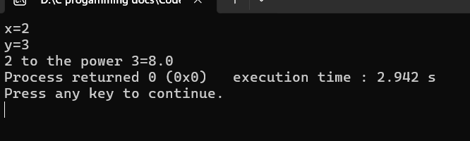

Problem No: 15
Problem Name: Write a program that read any number
and display its square root.

Source Code:
#include <stdio.h>
#include <math.h>

int main()
{
float x;
printf("Enter any number: ");
scanf("%f", &x);
printf("Square root of %.2f = %.2f\n",x,sqrt(x));
return 0;
}

Output :
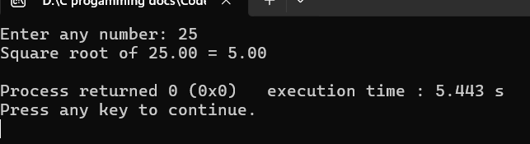

Problem No: 16
Problem Name: Write a program that read any number x
and display e to the power x.

Source Code:
#include <stdio.h>
#include <math.h>

int main()
{
float x;
printf("Enter any number: ");
scanf("%f", &x);
printf("e to the power%.2f=%.2lf",x,exp(x));
return 0;
}

Output :
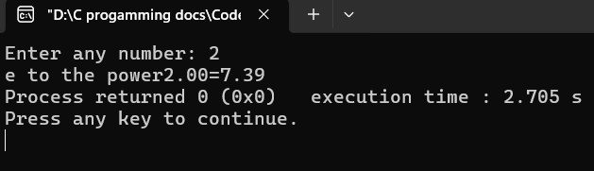

Problem No: 17
Problem Name: Write a program that read any number x
and display log(x).

Source Code:
#include <stdio.h>
#include <math.h>

int main()
{
double x;
printf("Enter any number x: ");
scanf("%lf", &x);

printf("log(%lf) = %lf\n",x,log(x));
return 0;
}

Output :
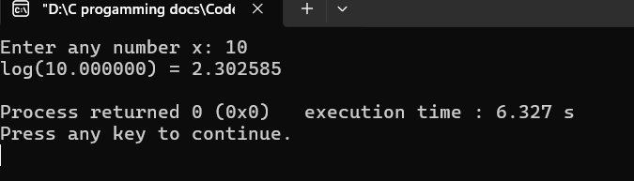

Problem No: 18
Problem Name: Write a program that read any number x
and display log10(x).

Source Code:
#include <stdio.h>
#include <math.h>

int main()
{
double x;
printf("Enter any number x: ");
scanf("%lf", &x);

printf("log10(%lf) = %lf\n",x,log10(x));
return 0;
}

Output :
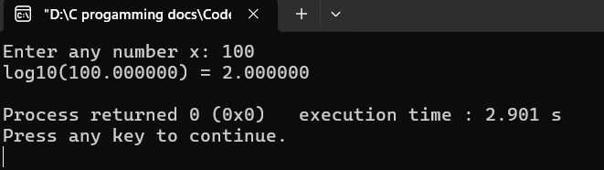

If , If…….Else

Problem No: 01
Problem Name: Write a program that read an integer
and print odd or even.
Source Code:
#include <stdio.h>
int main() {
int x;
printf("Enter an integer: ");
scanf("%d", &x);
if (x % 2 == 0) {
printf("%d is even.\n", x);
} else {
printf("%d is odd.\n", x);
}
return 0;
}

Output :
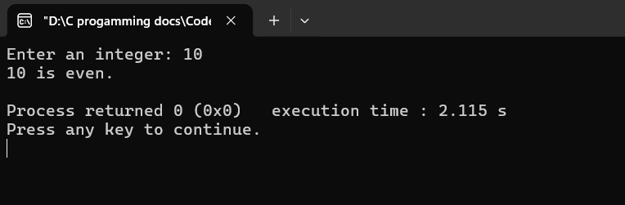
Problem No: 02
Problem Name: Write a program that read two numbers
and display maximum.

Source Code:
#include <stdio.h>
int main()
{
int a,b;
printf("Enter first number:");
scanf("%d",&a);
printf("Enter second number:");
scanf("%d",&b);
if (a > b)
printf("Maximum = %d\n", a);
else
printf("Maximum = %d\n", b);
return 0;
}

Output :
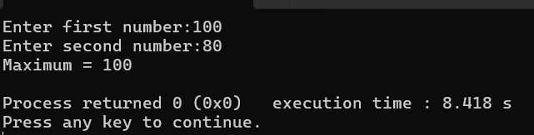

Problem No: 03
Problem Name: Write a program that read two numbers
and display minimum.

Source Code:
#include <stdio.h>

int main()
{
int a,b;
printf("Enter first number:");
scanf("%d",&a);
printf("Enter second number:");
scanf("%d",&b);

if (a < b)
printf("Minimum = %d\n", a);
else
printf("Minimum = %d\n", b);
return 0;
}

Output :
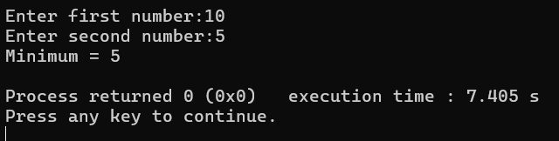
Problem No: 04
Problem Name: Write a program that read three numbers
and display maximum.

Source Code:
#include <stdio.h>
int main()
{
int a,b,c;
printf("Enter first number:");
scanf("%d",&a);
printf("Enter second number:");
scanf("%d",&b);
printf("Enter second number:");
scanf("%d",&c);

if (a > b && a > c)
printf("Maximum = %d\n", a);
else if (b > c)
printf("Maximum = %d\n", b);
else
printf("Maximum = %d\n", c);
return 0;
}

Output :
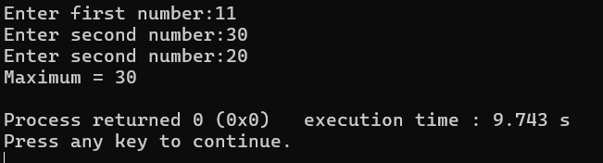
Problem No: 05
Problem Name: Write a program that read three numbers
and display minimum.

Source Code:
#include <stdio.h>
int main()
{
int a,b,c;
printf("Enter first number:");
scanf("%d",&a);
printf("Enter second number:");
scanf("%d",&b);
printf("Enter second number:");
scanf("%d",&c);

if (a < b && a < c)
printf("Minimum = %d\n", a);
else if (b < c)
printf("Minimum = %d\n", b);
else
printf("Minimum = %d\n", c);
return 0;
}

Output :
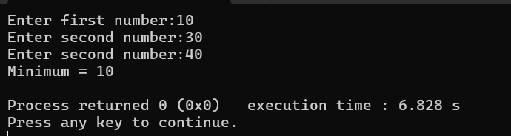
Problem No: 06
Problem Name: Write a program that read three numbers
and display medium.
Source Code:
#include <stdio.h>
int main() {
int a, b, c;
printf("Enter first number: ");
scanf("%d", &a);
printf("Enter second number: ");
scanf("%d", &b);
printf("Enter third number: ");
scanf("%d", &c);

if ((a > b && a < c) || (a < b && a > c))
printf("Medium = %d\n", a);
else if ((b > a && b < c) || (b < a && b > c))
printf("Medium = %d\n", b);
else
printf("Medium = %d\n", c);
return 0;
}

Output :
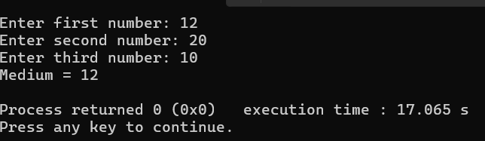
Problem No: 07
Problem Name: Write a program that read marks and
display pass or fail.

Source Code:
#include <stdio.h>

int main() {
int marks;

printf("Enter your marks: ");
scanf("%d", &marks);

if (marks >= 50)
printf("Pass\n");
else
printf("Fail\n");

return 0;
}

Output :
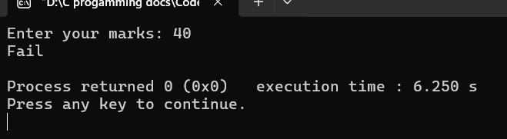
Problem No: 08
Problem Name:

Source Code:
#include <stdio.h>

int main() {
int marks;

printf("Enter your marks: ");
scanf("%d", &marks);

if (marks >= 50)
printf("%d / 50 = pass\n", marks);
else
printf("%d / 50 = Fail\n", marks);

return 0;
}

Output :
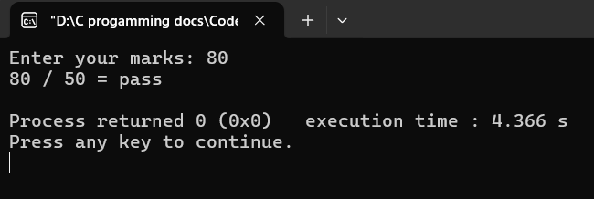
Problem No: 09
Problem Name: Write a program that read mark and
display result in grade.

Source Code:
#include <stdio.h>

int main() {
int mark;

printf("Enter your mark: ");
scanf("%d", &mark);

if (mark >= 90)
printf("Grade: A+\n");
else if (mark >= 80)
printf("Grade: A\n");
else if (mark >= 70)
printf("Grade: B\n");
else if (mark >= 60)
printf("Grade: C\n");
else if (mark >= 50)
printf("Grade: D\n");
else
printf("Grade: F (Fail)\n");

return 0;
}

Output :

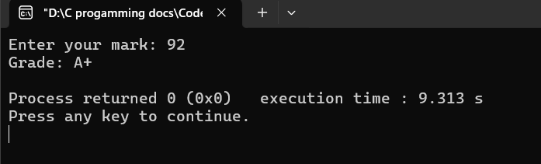

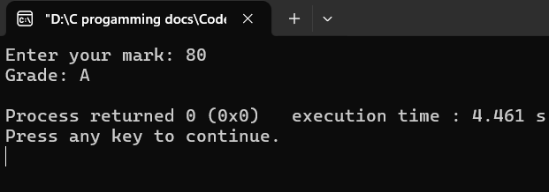

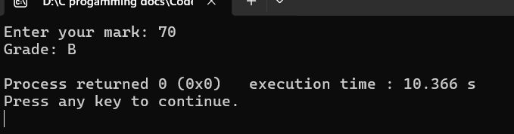

Problem No: 10
Problem Name: Write a program that read any year and
display leap year or not year leap.

Source Code:
#include <stdio.h>

int main() {
int year;

printf("Enter a year: ");
scanf("%d", &year);

if ((year % 4 == 0 && year % 100 !=0) || (year % 400 == 0))
printf("%d is a leap year\n", year);

else
printf("%d is not a leap year\n", year);

return 0;
}

Output :

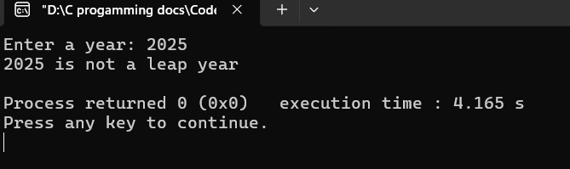

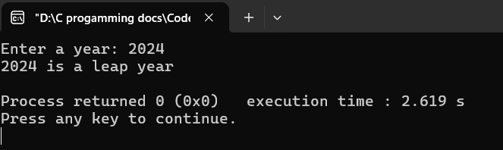

Problem No: 01
Problem Name: Write a program that read three numbers
(a, b, c) and determine the roots of the
quadratic equation: ax^2+bx+c=0.

Source Code:
#include <stdio.h>
#include <math.h>

int main() {
double a, b, c, discriminant, root1, root2, realPart, imagPart;

printf("Enter coefficients a, b, c: ");
scanf("%lf %lf %lf", &a, &b, &c);

if (a == 0) {
printf("Not a quadratic equation.\n");
return 0;
}
discriminant = b*b - 4*a*c;
if (discriminant > 0) {
// Two real and distinct roots
root1 = (-b + sqrt(discriminant)) / (2*a);
root2 = (-b - sqrt(discriminant)) / (2*a);
printf("Roots are real and distinct:\n");
printf("Root1 = %.2lf\n", root1);
printf("Root2 = %.2lf\n", root2);
} else if (discriminant == 0) {
// One real root
root1 = -b / (2*a);
printf("Roots are real and equal:\n");
printf("Root = %.2lf\n", root1);
} else {
// Complex roots
realPart = -b / (2*a);
imagPart = sqrt(-discriminant) / (2*a);
printf("Roots are complex:\n");
printf("Root1 = %.2lf + %.2lfi\n", realPart, imagPart);
printf("Root2 = %.2lf - %.2lfi\n", realPart, imagPart);
}
return 0;
}

Output :
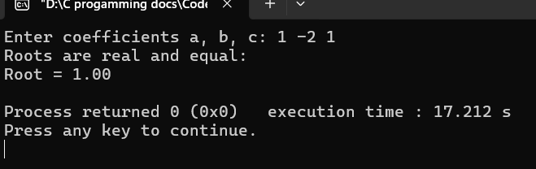
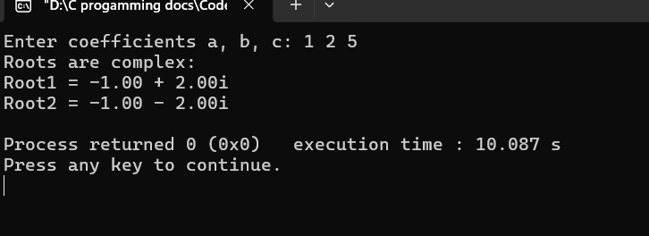

Conditional Operator

Problem No: 01
Problem Name: Write a program that reads an integer and prints odd or even.

Source Code:
#include <stdio.h>

int main() {
int n;

printf("Enter an integer: ");
scanf("%d", &n);
(n % 2 == 0) ? printf("Even\n") : printf("Odd\n");

return 0;
}

Output :
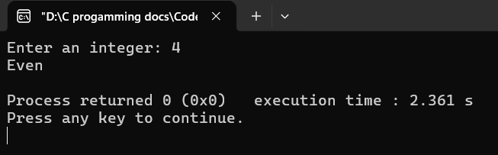

Problem No: 02
Problem Name: Write a program that reads two numbers and displays maximum.

Source Code:
#include <stdio.h>

int main() {
int a , b;

printf("Enter an number: ");
scanf("%d %d", &a, &b);
(a > b) ? printf("Maximum = %d\n", a) : printf("Maximum = %d\n" , b);

return 0;
}

Output :
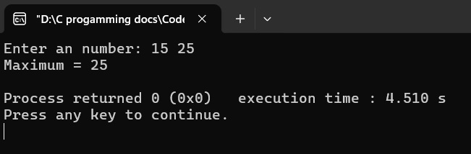

Problem No: 03
Problem Name: Write a program that reads two numbers and displays minimum.

Source Code:
#include <stdio.h>

int main() {
int a , b;

printf("Enter an number: ");
scanf("%d %d", &a, &b);
(a < b) ? printf("Minimum = %d\n", a) : printf("Minimum = %d\n" , b);

return 0;
}

Output :
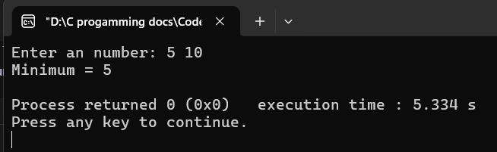

Problem No: 04
Problem Name: Write a program that reads three numbers and displays maximum.

Source Code:
#include <stdio.h>

int main() {
int a , b, c, max;

printf("Enter an number: ");
scanf("%d %d %d", &a, &b, &c);
max = (a > b) ? ((a > c) ? a : c) : ((b > c) ? b : c);
printf("Maximum = %d\n" , max);
return 0;
}

Output :
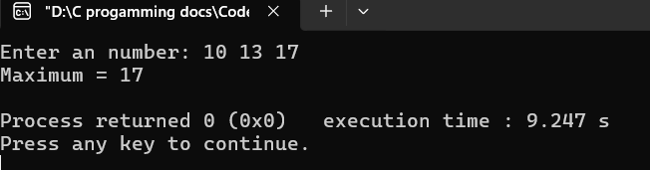

Problem No: 05
Problem Name: Write a program that reads three numbers and displays minimum.

Source Code:
#include <stdio.h>

int main() {
int a , b, c, min;

printf("Enter an number: ");
scanf("%d %d %d", &a, &b, &c);
min = (a < b) ? ((a < c) ? a : c) : ((b < c) ? b : c);
printf("Minimum = %d\n" , min);
return 0;
}

Output :
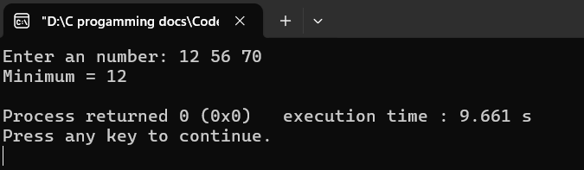

Problem No: 06
Problem Name: Write a program that reads three numbers and displays medium.

Source Code:
#include <stdio.h>

int main() {
int a , b, c, medium;

printf("Enter an number: ");
scanf("%d %d %d", &a, &b, &c);
medium = (a > b) ? ((a < c) ? a : ((b > c) ? b : c))
: ((a > c) ? a : ((b < c) ? b : c));
printf("Medium = %d\n" , medium);
return 0;
}

Output :
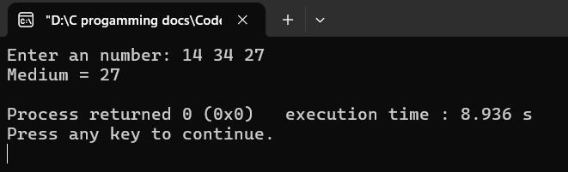

Problem No: 07
Problem Name: Write a program that reads mark and displays pass or fail.

Source Code:
#include <stdio.h>

int main() {
int mark;

printf("Enter a mark: ");
scanf("%d", &mark);
(mark >= 50) ? printf("Pass\n") : printf("Fail\n");
return 0;
}

Output :
